**LunaH-Map**

*Lunar Polar Hydrogen Mapper*



**Mini-Neutron Spectrometer** **Interface Control Document**

**Mission Document ID:** LUNAHMAP\_PLD\_ICD

|  |
| --- |
| **WARNING**  This document contains controlled technical data as defined in the applicable U.S. Export Control Regulations. Export of this material is restricted by those regulations. This material is not to be exported to foreign persons without appropriate export authority (e.g., an export license or other approval issued by the U.S. Government). |

**Approved by:**

|  |  |
| --- | --- |
| Craig Hardgrove  LunaH-Map Principal Investigator  Arizona State University | Igor Lazbin  LunaH-Map Chief Engineer  Arizona State University |
| Erik Johnson  Mini-NS Lead  Radiation Monitoring Devices | Name  Title  Affiliation |
| Name  Title  Affiliation | Name  Title  Affiliation |
|  |  |
|  |  |

**REVISION HISTORY:**

|  |  |  |  |
| --- | --- | --- | --- |
| **Revision** | **Release Date** | **Author(s)** | **Description** |
| 1 | 5/20/2016 | Erik B Johnson | Initial Draft of ICD |
| 2.0 | 6/30/2016 | Erik B Johnson | Revision 2.0 |
| 3.0 | 10/19/2016 | Erik B Johnson | Revision 3.0 |
| 4.0 | 2/10/2017 | Erik B Johnson | Revision 4.0 –  Updates  Software commands  Electrical interface |
| 5.0 | 3/30/2017 | Erik B. Johnson | No updates |
| 5.1. | 4/6/2017 | Erik B Johnson | Documenting recent changes associated with cables, connectors, and shielding, affecting the mechanical structures. |
| 5.4 | 7-17-2017 | Graham Stoddard | Updating software commands and data products. Included new section concerning the base level usage of the commands and their return values. |
|  |  |  |  |
|  |  |  |  |
|  |  |  |  |
|  |  |  |  |
|  |  |  |  |
|  |  |  |  |

**LIST OF TBDs, TBRs, & OPEN ITEMS:**

|  |  |  |
| --- | --- | --- |
| **Section ID** | **Description of TBD/TBR/Open Item** | **Expected Resolution Date** |
| 0 | Completion of the thermal interface. | 8/31/2017 |
| 5 | Metal on the instrument components can be connected via bolts or braided cable. | 8/31/2017 |
| 6 | Clarification of the science and non-science operation, including time of operation. | 8/31/2017 |
| 6.2 | Complete the software and document the operation and configuration. | 8/31/2017 |
| 7 | Complete the software commands, syntax, descriptions, and arguments. | 8/31/2017 |
| 9 | Complete the detailed operations manual. | 8/31/2017 |
| 9 | Complete manual on error handling. | 8/31/2017 |
| 9 | Generate a FAQ. | 8/31/2017 |
|  | Electrical Interface- All sections need to be updated | 8/31/2017 |
|  |  |  |
|  |  |  |
|  |  |  |
|  |  |  |
|  |  |  |
|  |  |  |
|  |  |  |
|  |  |  |
|  |  |  |

**DRAFT**

***TABLE of CONTENTS***

[1 Hardware Overview 8](#_Toc482025918)

[2 Mechancial Interface 11](#_Toc482025919)

[3 Thermal Interface 13](#_Toc482025920)

[4 electrical connector PINOUTs 14](#_Toc482025921)

[4.1 Power Port (15-pin Power: GlenAir MWDM2L-15P-4J5-18P) 14](#_Toc482025922)

[4.2 serial port (15-pin Power: GlenAir MWDM2L-15P-4J5-18P) 15](#_Toc482025923)

[5 Grounding 16](#_Toc482025924)

[6 Operation Overview 17](#_Toc482025925)

[6.1 Operation Overview 17](#_Toc482025926)

[6.1.1 Checkout/Calibration 17](#_Toc482025927)

[6.1.2 Background/Diagnostics/Temp 17](#_Toc482025928)

[6.1.3 Science Mode 17](#_Toc482025929)

[6.1.4 Transfer Data 17](#_Toc482025930)

[6.2 Software and Configuration 19](#_Toc482025931)

[7 Software Commands 21](#_Toc482025932)

[8 Data Products 27](#_Toc482025933)

[8.1 Data products 27](#_Toc482025934)

[8.2 File System Logs 28](#_Toc482025935)

[8.3 DAQ UART Buffer Error! Bookmark not defined.](#_Toc482025936)

[8.3.1 Per Second Structure **Error! Bookmark not defined.**](#_Toc482025937)

[8.3.2 End of DAQ Histogram **Error! Bookmark not defined.**](#_Toc482025938)

[8.4 DAQ Local Data Logging 29](#_Toc482025939)

[8.4.1 FileName 29](#_Toc482025940)

[8.4.2 File Structure 29](#_Toc482025941)

[8.5 Statistics per detector 31](#_Toc482025942)

[9 Detailed Operation 32](#_Toc482025943)

[9.1 Start Up Procedure 32](#_Toc482025944)

[9.2 Reset Procedure 32](#_Toc482025945)

[9.3 Checkout/Calibration Error! Bookmark not defined.](#_Toc482025946)

[9.4 Background/Diagnostics 32](#_Toc482025947)

[9.5 Science Mode 33](#_Toc482025948)

[9.6 Transfer Data Error! Bookmark not defined.](#_Toc482025949)

[10 References 35](#_Toc482025950)

[11 Appendix 36](#_Toc482025951)

[11.1 DataSheets 36](#_Toc482025952)

[11.1.1 MWDM2L-15P-4J5-18P 36](#_Toc482025953)

[11.1.2 Cortex A9 Technical Manual 36](#_Toc482025954)

[11.1.3 36](#_Toc482025955)

[11.2 Component Operation 37](#_Toc482025956)

[11.2.1 Overview 37](#_Toc482025957)

[11.2.2 Transfer Data 38](#_Toc482025958)

[11.2.3 Setting Temperature 38](#_Toc482025959)

[12 Development Kit User Manual 40](#_Toc482025960)

[12.1 SetUp: 40](#_Toc482025961)

[12.2 Collecting Data: 40](#_Toc482025962)

***TABLE of FIGURES***

[Figure 1: Instrument Position in CubeSat 8](#_Toc479373388)

[Figure 2: Detector Connector Ports 9](#_Toc479373389)

[Figure 3: Electrical Ports Overview 10](#_Toc479373390)

[Figure 4: Detector Grounding Diagram 16](#_Toc479373391)

[Figure 5: Operation Overview 17](#_Toc479373392)

[Figure 6: Top-Level Diagram of Software Operation 19](#_Toc479373393)

[Figure 7: Temperature Set Loop 20](#_Toc479373394)

[Figure 8: Data Acquistion Loop 20](#_Toc479373395)

***TABLE of TABLES***

[Table 1: Power Consumption per Detector. 10](#_Toc479373382)

[Table 2: Pin out for Power Connector 14](#_Toc479373383)

[Table 3: Pin out for Data Connectors 15](#_Toc479373384)

[Table 4: Data Products 27](#_Toc479373385)

[Table 5: Science Data Product Aggregated Sizes Error! Bookmark not defined.](#_Toc479373386)

[Table 6: Power Consumption per Detector. 37](#_Toc479373387)

***ACRONYMS and ABBREVATIONS***

ADC = Analog to Digital Converter

CAD = Computer Assisted Drawing

CLYC = Cs2LiYCl6:Ce

PMT = Photomultiplier Tube

POR = Power On Reset

# Hardware Overview

*Instrument* – The complete thermal and epi-thermal detectors. This has been termed mini-neutron spectrometer, or mini-NS.

*Detector* – The set of CLYC crystals coupled to photomultiplier tubes and readout using one analog to digital converter. There are two detectors in the instrument. The detector consists of the HV supply, amplifier, thermal sensors, thermal electric coolers, relays, ADC, and Zynq.

*Module* – A single CLYC and PMT component of the detector. This will include the components that will directly interface to the PMT, such as the voltage divider network, first stage amplifiers and the comparators.

The LunaH Map cubesat is equipped with a neutron spectrometer. The most recent CAD of the spectrometer is shown in Figure 1, which consists of two detectors. The spectrometers will face the moon, and one of the detectors will have a cadmium sheet on the face of the detector pointing toward the moon. The two detectors are labelled as CLYC-1 and CLYC-2. The instrument is mounted as a module integral to the mechanical structure of the cubesat. The detector volume is set by the science goals, and requiring the cubesat structure become a part of the instrument support frame will allow the instrument to meet the volume requirement as well.

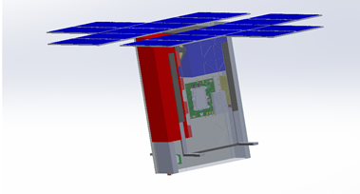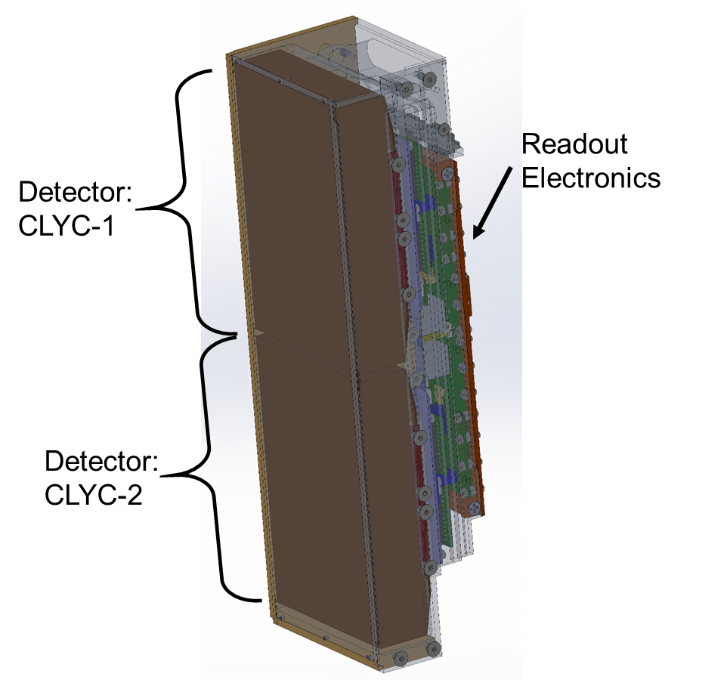

Figure 1: Instrument Position in CubeSat

There are three micro-D connectors on the Mini-NS. Take note of the orientation of the instrument in the spacecraft from Figure 1, as the port for detector CLYC-1 is on the opposite side to the port for CLYC-2. The power port is another micro-D connector, yet the connector will be mounted upside down. Multiple conductors are used to deliver power to the Mini-NS.

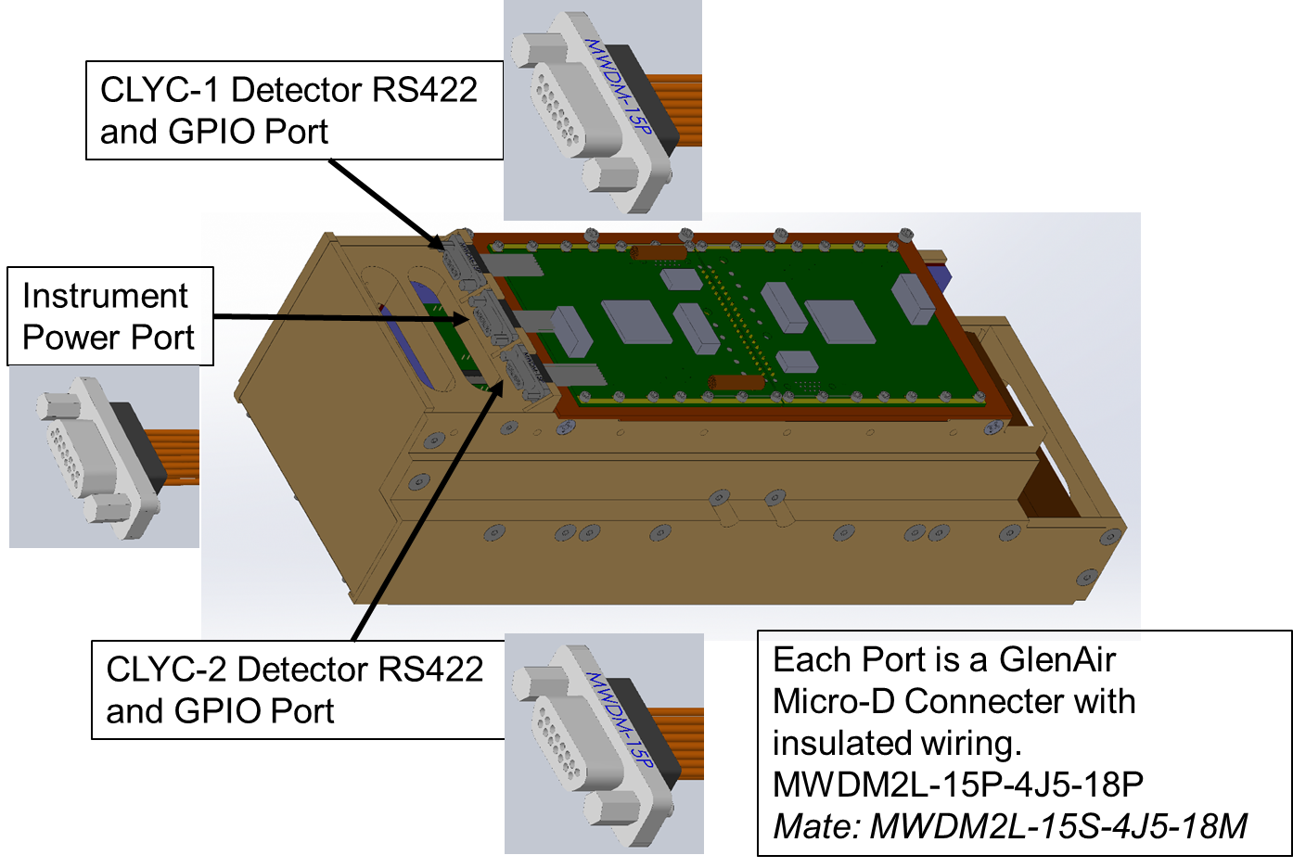

Figure 2: Detector Connector Ports

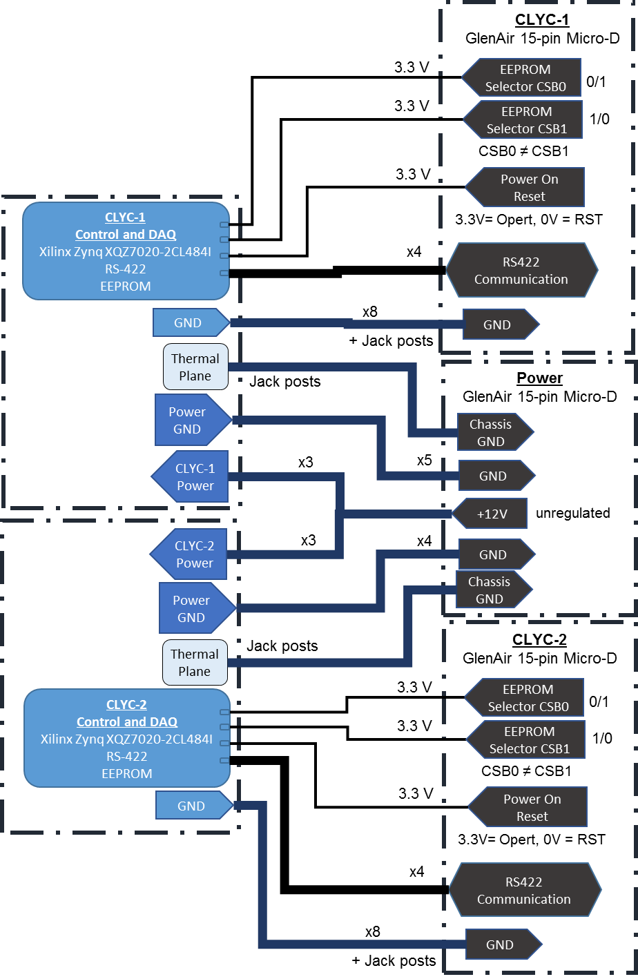

Figure 3: Electrical Ports Overview

Table : Power Consumption per Detector.

|  |  |  |  |  |  |  |
| --- | --- | --- | --- | --- | --- | --- |
| **Power Configuration** | **Min. Supply Current (A)** | **Max. Supply Current (A)** | **Min. Supply Power (W)** | **Max. Supply Power (W)** | **Max. Cold-Side Power (W)** | **Max. Hot-Side Power (W)** |
| **Transfer Data** |  | 0.2 |  | 2.4 | 0.0 | 2.4 |
| **Set Temp** | 0.2 | 0.7 | 2.4 | 8.4 | 0.0 | 8.4 |
| **Data Acq.** | 0.4 | 0.9 | 4.8 | 10.8 | 1.5 | 9.3 |

MAXIUM POWER DRAW: 10.8 W per detector.

# Mechancial Interface

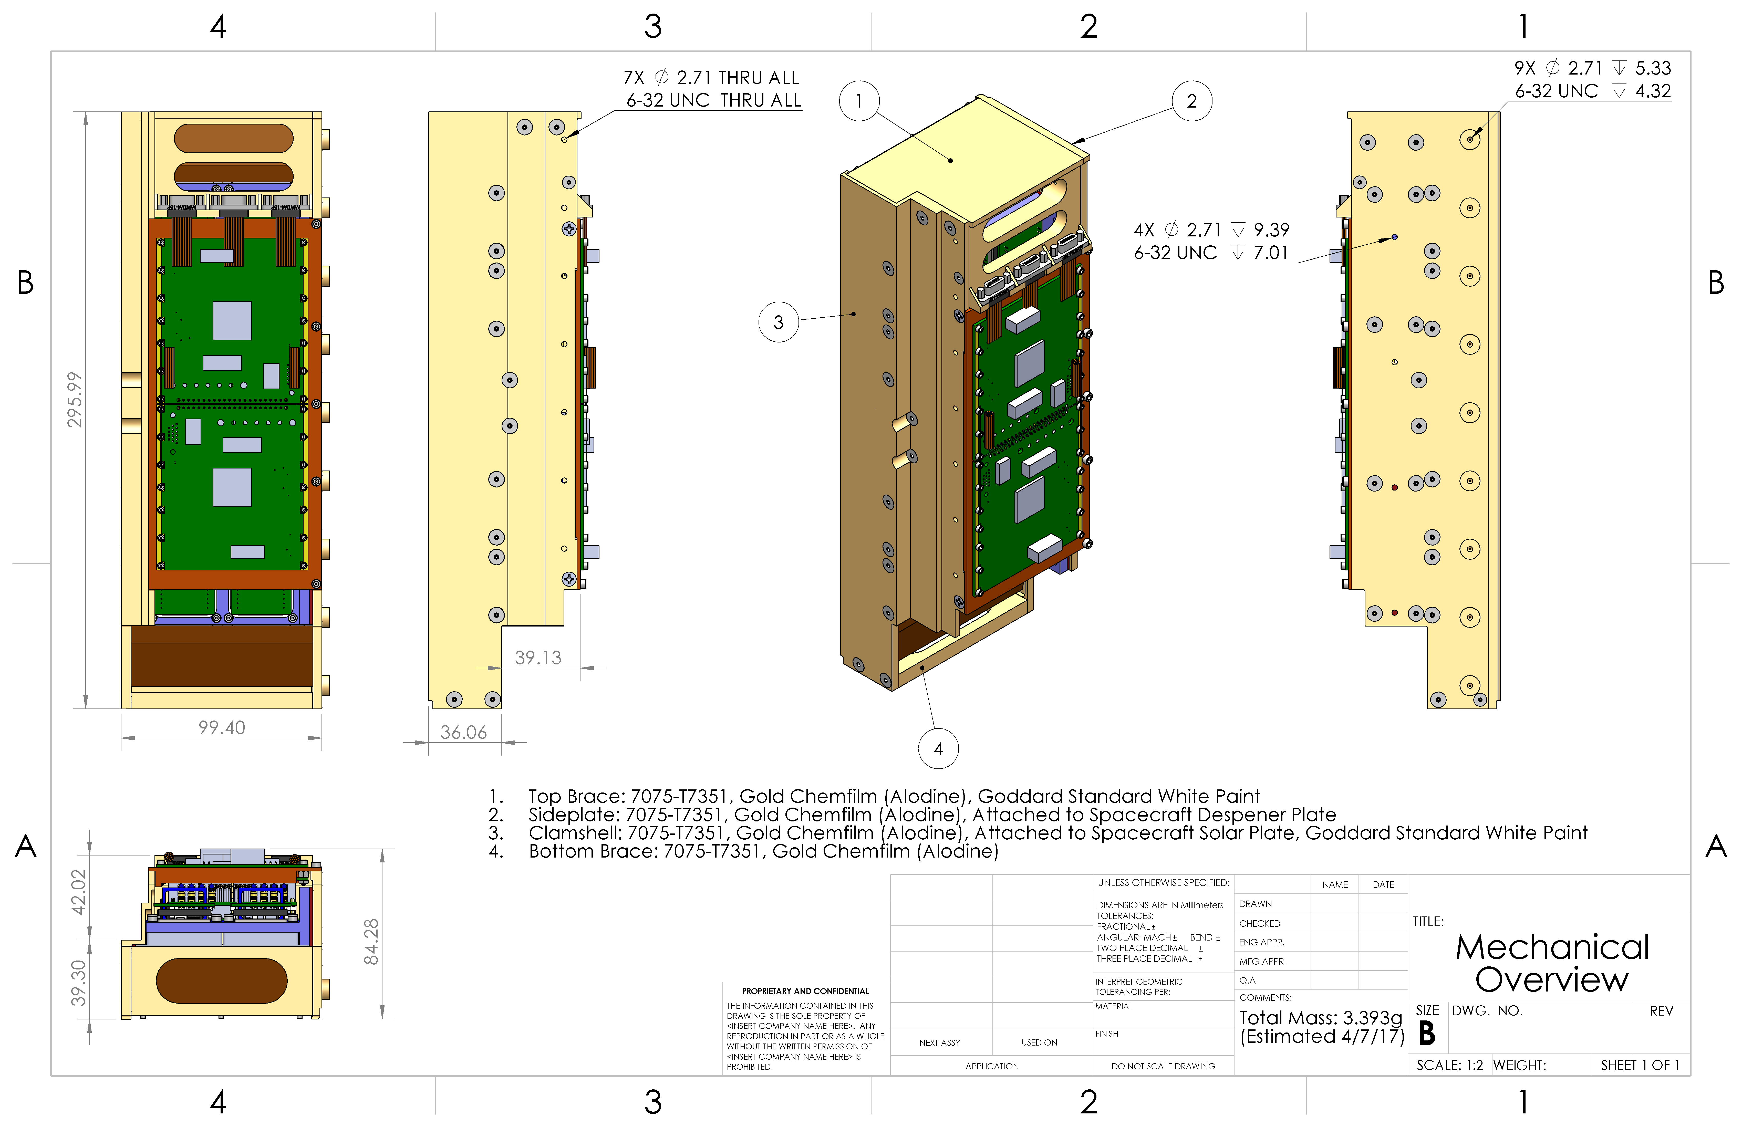

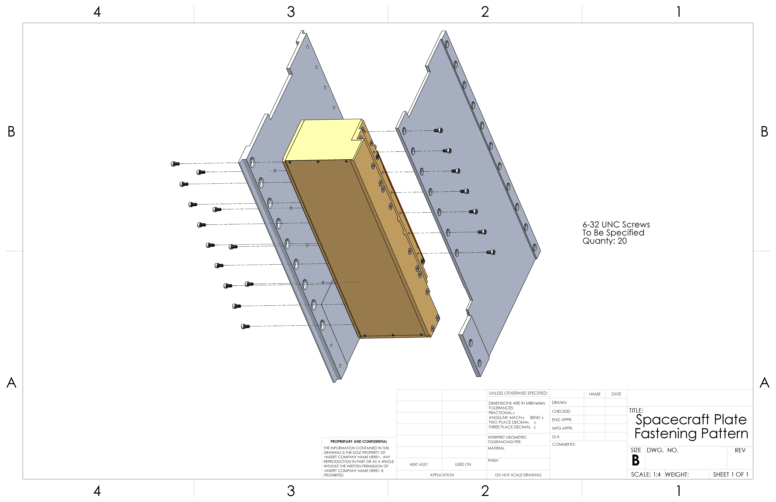

# Thermal Interface

The analog board and detector modules are thermally isolated from the rest of the instrument and spacecraft. The following drawing provides the data for assessing the thermal connection from the thermally isolated components to the spacecraft chassis. The digital board has a strong thermal connection to the spacecraft side panels.

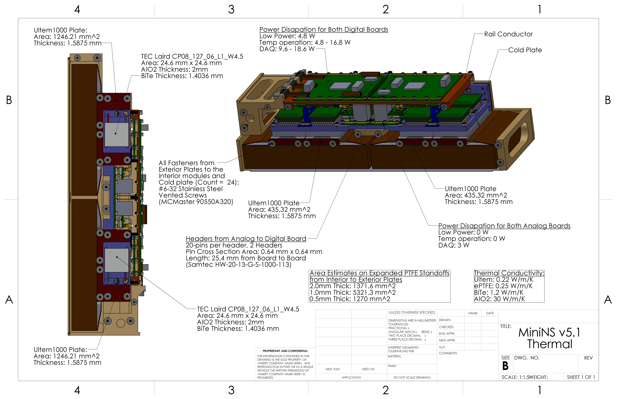

# electrical connector PINOUTs

## Power Port (15-pin Power: GlenAir MWDM2L-15P-4J5-18P)

|  |  |  |  |  |  |  |  |  |  |
| --- | --- | --- | --- | --- | --- | --- | --- | --- | --- |
| MWDM | 2 | L | 15 | P | 4 | J | 5 | 18 | P |
| Micro-D | Nickel | LCP  30% Glass-Filled Liquid Crystal Polymer | Contact Number | Pin | #24 AWG | M22759/33 600VRMS Modified Cross-Linked Tefzel | Color-Coded Stripes per MIL-STD-681 | 18” | Jackpost |

Mate: MWDM2L-15S-4J5-18M (Socket with Hex Head Jackscrew)

Table : Pin out for Power Connector

|  |  |  |  |  |
| --- | --- | --- | --- | --- |
| Purpose | Pin | K:\Research Files\NASA\C16-018 LunaH-Map\CAD Models\02_23_2017 Flight Unit v5.1\Digital Board\mwdm2l-15p-6e5-18.PNG | Pin | Purpose |
| |  |  | | --- | --- | | CLYC-2 GND | 9 | | CLYC-2 GND | 10 | | CLYC-2 GND | 11 | | CLYC-1 GND | 12 | | CLYC-1 GND | 13 | | CLYC-1 GND | 14 | | CLYC-1 GND | 15 | | | 1 | CLYC-2 +12V |
| 2 | CLYC-2 +12V |
| 3 | CLYC-2 +12V |
| 4 | CLYC-2 GND |
| 5 | CLYC-1 GND |
| 6 | CLYC-1 +12V |
| 7 | CLYC-1 +12V |
| 8 | CLYC-1 +12V |
|  | |

Jackscrews are connected to Chassis Ground.

## serial port (15-pin Power: GlenAir MWDM2L-15P-4J5-18P)

|  |  |  |  |  |  |  |  |  |  |
| --- | --- | --- | --- | --- | --- | --- | --- | --- | --- |
| MWDM | 2 | L | 15 | P | 4 | J | 5 | 18 | P |
| Micro-D | Nickel | LCP  30% Glass-Filled Liquid Crystal Polymer | Contact Number | Pin | #24 AWG | M22759/33 600VRMS Modified Cross-Linked Tefzel | Color-Coded Stripes per MIL-STD-681 | 18” | Jackpost |

Mate: MWDM2L-15S-4J5-18M (Socket with Hex Head Jackscrew)

Table : Pin out for Data Connectors

|  |  |  |  |  |
| --- | --- | --- | --- | --- |
| Purpose | Pin | K:\Research Files\NASA\C16-018 LunaH-Map\CAD Models\02_23_2017 Flight Unit v5.1\Digital Board\mwdm2l-15p-6e5-18.PNG | Pin | Purpose |
| |  |  | | --- | --- | | RS422 RX\_P | 9 | | GND | 10 | | GND | 11 | | RS422 TX\_N | 12 | | GND | 13 | | GND | 14 | | GND | 15 | | | 1 | GND |
| 2 | GND |
| 3 | RS422 RX\_N |
| 4 | GND |
| 5 | Power On Reset (POR) |
| 6 | RS422 TX\_P |
| 7 | EEPROM 2 (CS\_2) |
| 8 | EEPROM 1 (CS\_1) |
|  | |

Jackscrews are connected to GND.

# Grounding

There are two grounds associated with interfacing with the instrument. These include a chassis ground and ground (GND). The chassis ground is the native one associated with the instrument housing, but it should be noted that the chassis ground is used to dissipate heat from the electronics to the spacecraft. There is an unspecified capacitive or inductive impedance to chassis ground from the instrument electronics. There is a GND connection from power (+12V unregulated supply voltage) to the instrument, which is the power return ground, and a GND from the CD&H to the instrument. The instrument handles grounding internally after a regulated +5V is produced. Additional voltages are produced on the instrument, where return grounds for analog circuits on the instrument are isolated from GND indicated here.

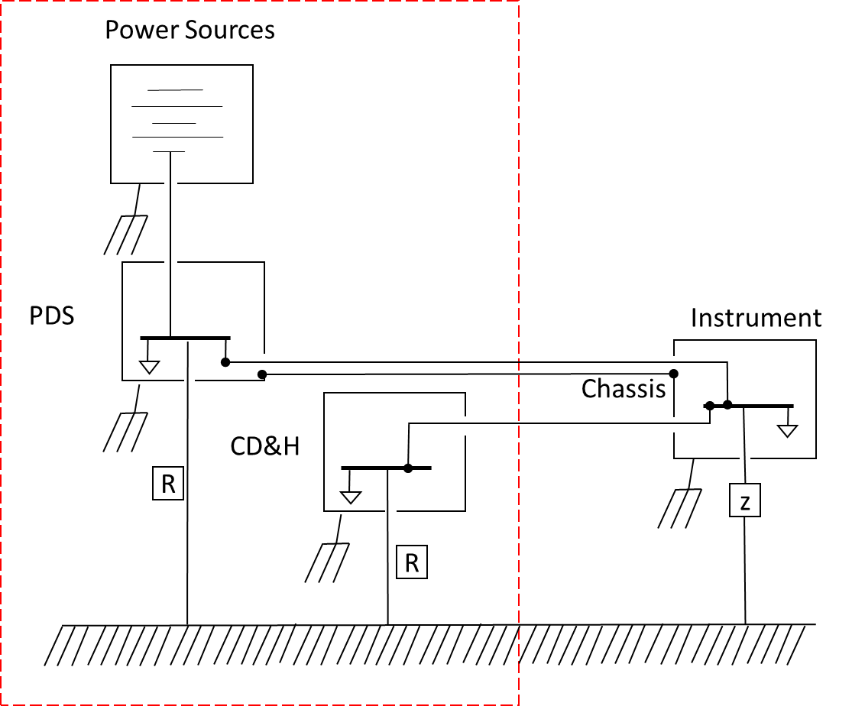

Figure 4: Detector Grounding Diagram

# Operation Overview

## Operation Overview

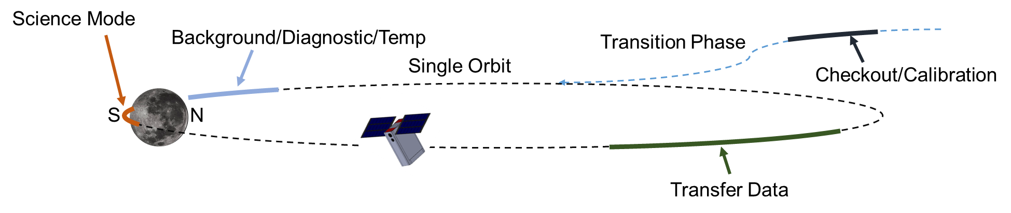

Figure 5: Operation Overview

The operation will consist of five different operations

1. Checkout/Calibration
2. Background/Diagnostic/Temp
3. Science mode
4. Transfer Data
5. Standby

### Checkout/Calibration

The instrument is turned on an operated during orbit transition. Data will be collected to assess the health of the instrument. Data will be captured from each detector module (CLYC/PMT) and transferred back to Earth. The data is processed on Earth to assess the health of the instrument and to upload any calibration corrections. The calibration point include gain adjustment for the PMTs, energy calibration, trigger thresholds, and cut values for reducing data.

### Background/Diagnostics/Temp

The instrument is operated near the moon before the science mode operation. The data collected in this region will serve for diagnostics purposes. During this operation, the instrument temperature can be set.

### Science Mode

The science mode operation will collect data for around the south pole of the moon. Counts are automatically transferred to UART buffer and data products are stored to SD Flash memory.

### transfer data

The transfer data operation allows the spacecraft to extract data from the SD Flash memory on the instrument for purposes to downlink to Earth.

### standby

The instrument will be in a low-power state (ADC off, etc.) where it will not respond to commands and will need to be energized to be interactive. This mode may be utilized when in portions of the orbit where the instrument serves no particular purpose.

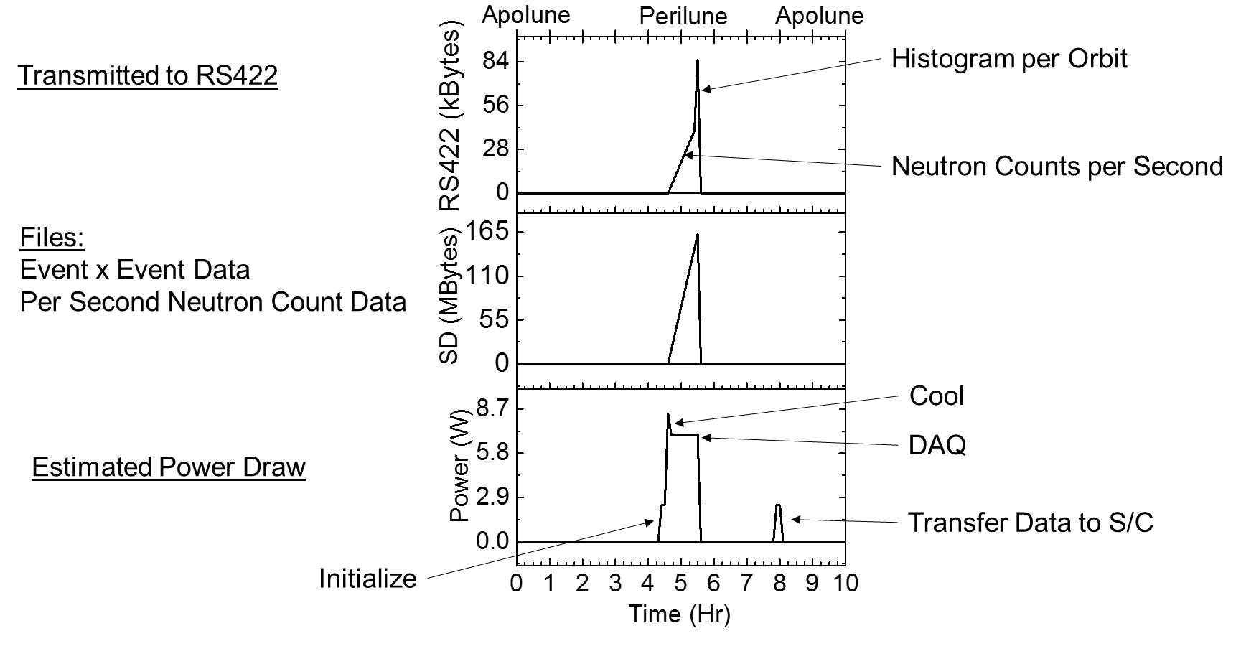

## Software and Configuration

The software environment operates on a Cortex Arm-9 Processor. The Cortex processor is packaged with a Xilinx Artix-7 FGPA interfaced using an AXI bus. The system family used for LunaH is a XC7Z020 Zynq. The code is developed using Xilinx’s Software Development Kit Version 2014.1. There is no operating system. The instrument uses a polling method for control.

Power On or Reset initiates a series of operations from boot loading the system from the selected EEPROM and executing the processor program. The initial steps in the program conducts a self-check, clears the RS422 line, sets default parameters, and sets up interrupts (primarily used with the FPGA). The code is then set in a polling state. The boxes highlighted in blue indicate where commands from the space craft are required.

The polling reads the UART buffer char by char and then stops at a new-line return (“\n”), or return (“\r”). Top level commands are broken into four categories (mode selection, system control, data file handling, and setting instrument parameters) and each command is further distinguished as a self-terminating or non-self-terminating process. Self-terminating processes are ones that will return back to the primary polling loop, see Figure 6, such as transferring a file or setting the trigger threshold. Data acquisition and setting the temperature enters a new polling loop see Figure 7 Figure 8. In this mode, data is acquired from the FPGA, processed and transferred to the RS422 write buffer. The full context of the data is written to the SD memory. After each RS422 write (1 per second), the RS422 buffer is polled. If the DAQ stop command was sent (“END\_*RealTime*”) by the spacecraft, the system will close out the data files and return to the primary poll. Capturing waveform (WF) or science data (DAQ), the acquisition process is the same. The “BREAK” command will cause any non-self-terminating function to return immediately.

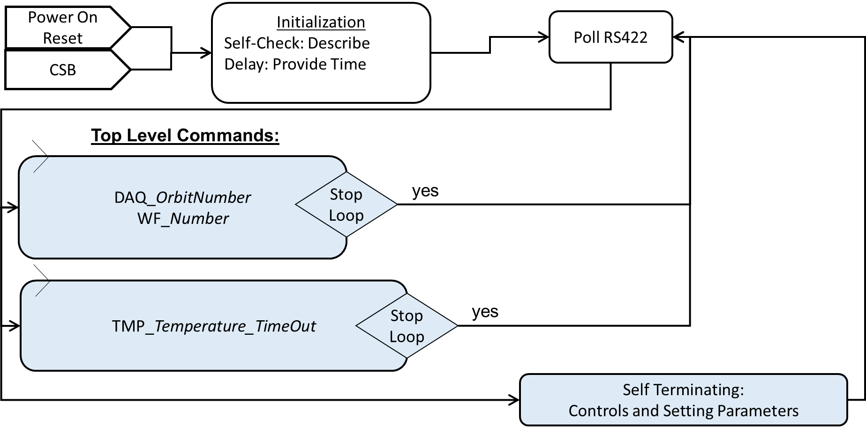

Figure 6: Top-Level Diagram of Software Operation

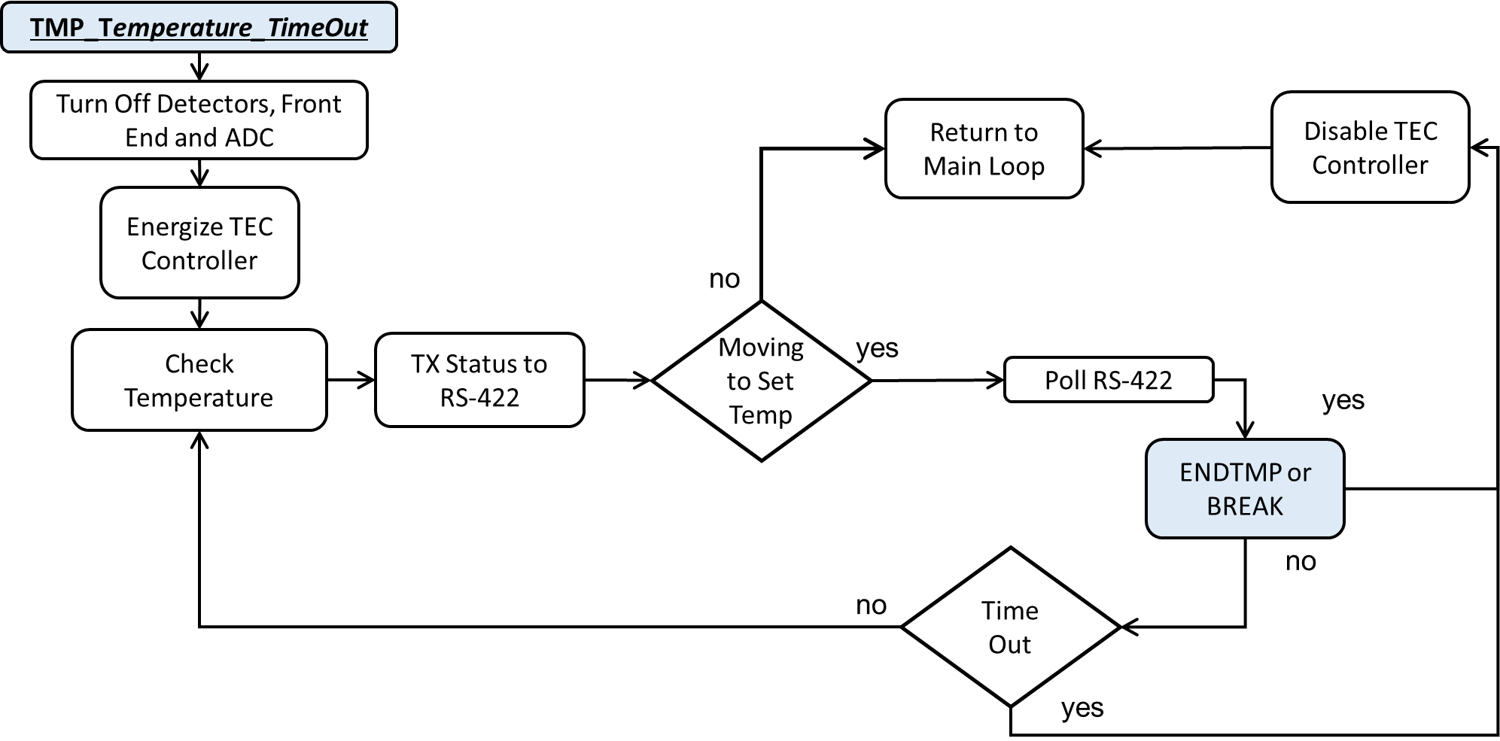

Figure 7: Temperature Set Loop

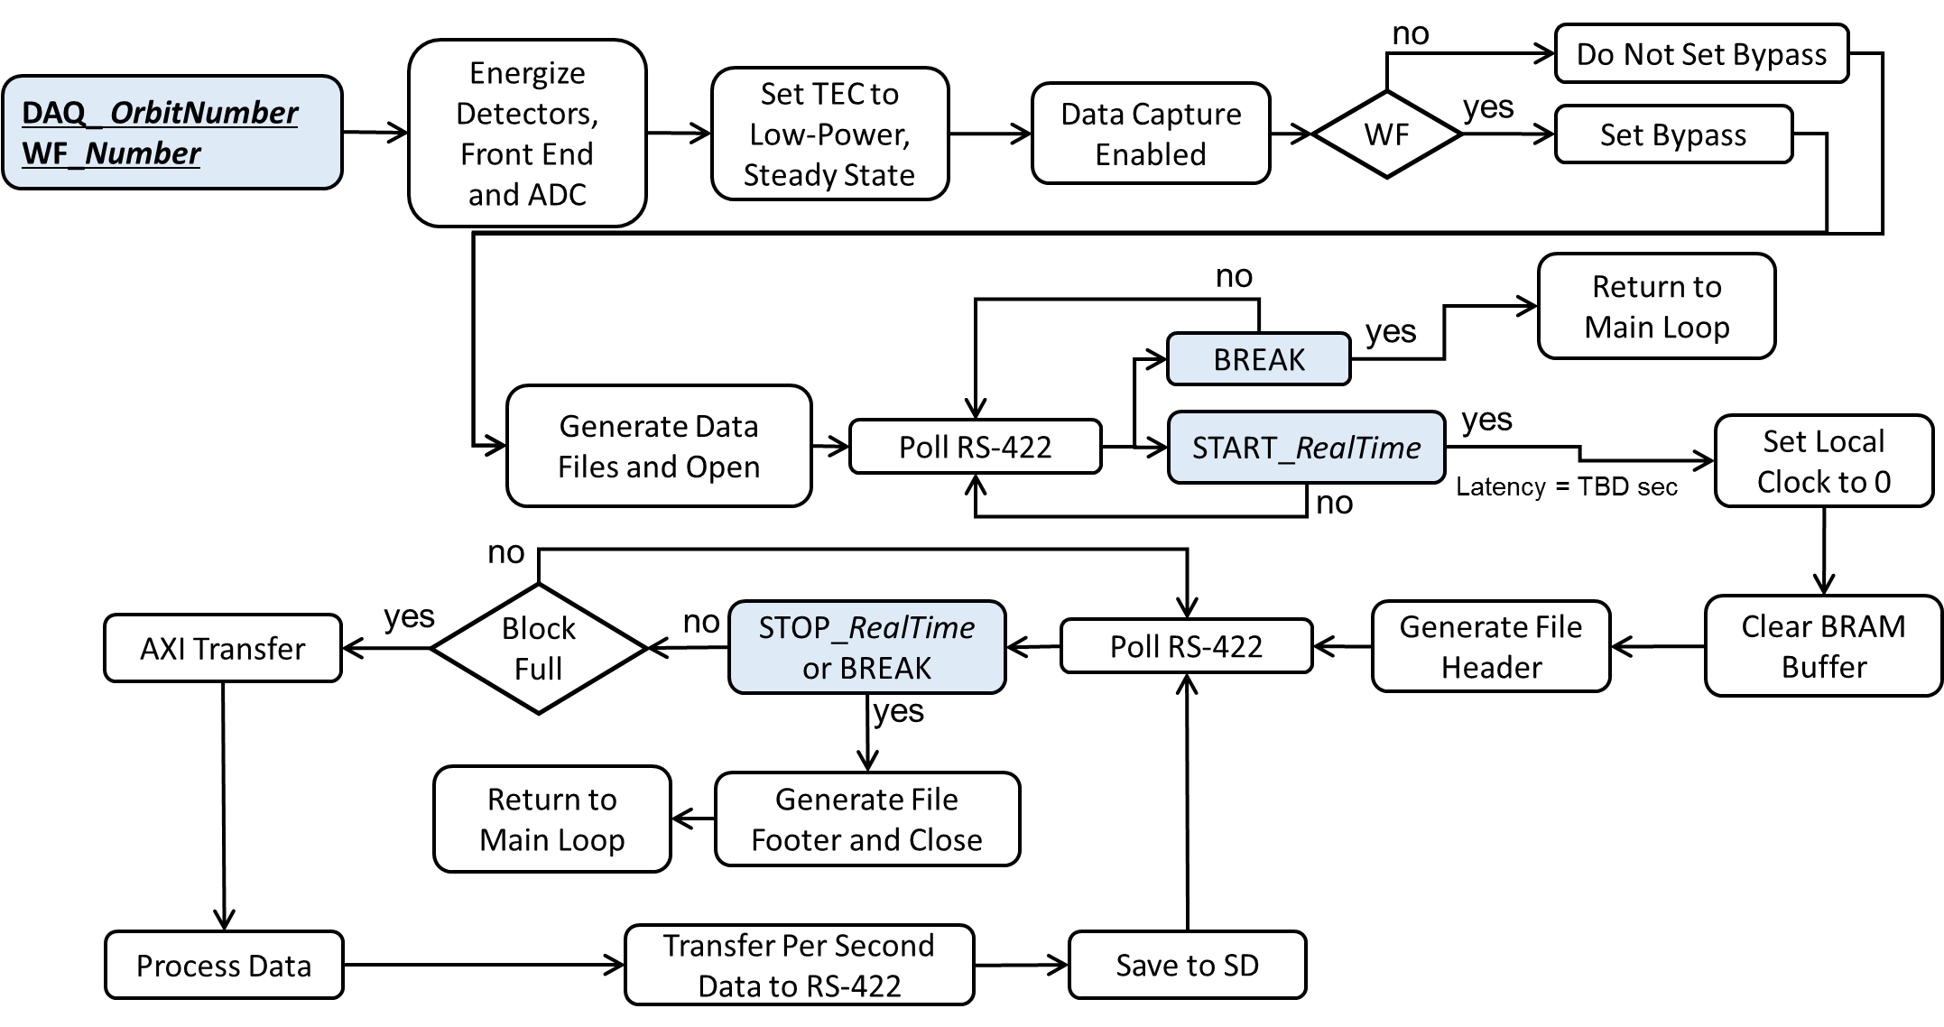

Figure 8: Data Acquistion Loop

# Software Commands

The commands are typically provided as ASCII, the other information to be passed from the spacecraft to the detectors are integer values up to, at least, 64-bit long. The values which are required are documented by this section and include the expected data type necessary for the value.

Each command has syntax that must be used to successfully interact with the system. On successful completion of a command, the return value will be written to the RS422; these return values are listed below each command.

If the syntax is incorrect or if the command fails, a return value of “FFFFFF” will be received by the user.

When breaking out of a command or process, “FAFAFA” will be received, indicating a successful break.

Statement of Health (SOH) data is returned every one second to inform the spacecraft that the instrument is powered on and active. This return is currently governed by a one second sleep statement.

RS422 2048 bytes or less. Are you aware that our C&DH system can only receive packets of maximum size 2048 bytes? When BCT pulls data from the Mini-NS, the data will need to be in packets of 2048 bytes or less.

TOP LEVEL

Capture Data (Loop)

Syntax: DAQ\_*OrbitNumber*

*OrbitNumber =* Spacecraft identifier for Orbit Number

Description: Science data files are created. Detector issues commands to enable the active components, set the thermal electric cooler into a static state, and prepare for data acquisition. The TEC steady state is static, low-current bleed on the TEC to mitigate the warming up of the instrument. A bypass is disabled within the FPGA logic to only allow processed integral data to stream from the FPGA to the processor. Once this command has been issued, the system waits to receive a further “START\_#” or “BREAK\_” command. These commands are described below. The value for orbit number must be less than 10000 to be accepted. This limit is based on the filename format.

Latency:

Return: *Filename\_cnt.bin\_Filename\_evt.bin*

*Filename=* Filename is based on *OrbitNumber,* detector controlled *RunNumber,* and data *TYPE.* A sample filename for an orbit number of 1234 and a run number of 4321 is “1234\_4321\_cnt.bin”.

Capture Waveforms (Loop)

Syntax: WF\_*OrbitNumber*

*OrbitNumber =* Spacecraft identifier for Data Set

Description: Waveform data file created. Detector issues commands to enable the active components, set the thermal electric cooler into a static state, and prepare for data acquisition. The TEC steady state is static, low-current bleed on the TEC to mitigate the warming up of the instrument. A bypass is enabled within the FPGA logic to inject the waveform data into the memory buffer. Once this command has been issued, the system waits to receive a further “START\_#” or “BREAK\_” command. These commands are described below. The value for orbit number must be less than 10000 to be accepted. This limit is based on the filename format.

Latency:

Return: *Filename\_wfd.bin*

*Filename=* Filename is based on *OrbitNumber,* detector controlled *RunNumber,* and data *TYPE.* A sample filename for an orbit number of 1234 and a run number of 4321 is “1234\_4321\_cnt.bin”.

Set Temperature (Loop)

Syntax: TMP\_*Temperature\_TimeOut*

*Temperature* = Target set temperature for the system

*TimeOut =* Time to force set temperature to stop operating (seconds)

Description: This command will disable the active components, enable the TEC controller. An attempt to set *Temperature* will be done. The system will loop until *Temperature* is reached, the *“*BREAK” or “ENDTMP” commands are received from the spacecraft or *TimeOut* is reached. At *TimeOut,* the process will disable the TEC controller and return to the main loop.

Latency:

Return: Four integer numbers: *AnalogTemp\_DigitalTemp\_AggregatedNeutrons\_LocalTme*; the numbers are the same as the Statement of Health (SOH) data, found in section 8.1, table 4. If the process receives “BREAK” the return value is “FAFAFA”. If the process is ended by the “ENDTMP” command, the return value is *AnalogTemp\_ElapsedLocalTime*, two integer numbers indicating the temperature of the analog components and the amount of time that has elapsed while looping. If the process finishes by reaching timeout, the return value is *AnalogTemp\_ElapsedLocalTime*, two integer numbers indicating the temperature of the analog components and the amount of time, *TimeOut*.

**System Control** (Self Terminating)

Get Status

Syntax: GETSTAT\_

Description: Return the partial status of the instrument. The status will provide information on some of the elements which are enabled. This can be cross referenced by the current draw from the instrument, which is not monitored by the instrument. This command has the same format as the “Statement of Health” data product and is intended to give a snapshot of the system.

Latency:

Return: Four integer numbers: *AnalogTemp\_DigitalTemp\_AggregatedNeutrons\_LocalTme*; the numbers are the same as the SOH data; see section 8.1, Table 4.

Disable Data Acquisition Components

Syntax: DISABLE\_ACT

Description: This command will disable the active components.

Latency:

Return: “AAAAAA” on success.

Disable TEC Components

Syntax: DISABLE\_TEC

Description: This command will disable the TEC components.

Latency:

Return: “AAAAAA” on success.

**Break**

Syntax: BREAK\_

Description: This command will break out of any looping process and return to the main polling loop.

Latency:

Return: “FAFAFA” on successfully breaking out of the process

Data File Handling (Self Terminating)

Transfer Data File

Syntax: TX\_*Filename*

*Filename =* OrbitNumber\_RunNumber.Type, DirectoryFile.txt, LogFile.txt

Description: Transfer data file stored on detector. All data is stored in the SD flash memory, and the spacecraft provides the orbit number, which is part of the filename. The spacecraft will keep track of the file names, but they will also be stored internally by the instrument in a file named “DirectoryFile.txt”. This internal log on the detector is used as an additional store for the filename. Accepts a string filename with appropriate file type specifier (.bin, .txt). The file specified by the user is checked to ensure it exists, if it does that file is transferred, else the failure string “FFFFFF” is returned. Data files are stored in binary format. Log files (“DirectoryFile.txt”, “LogFile.txt”) are stored in ASCII.

Latency:

Return: On success, contents of the file specified in ASCII format; “FFFFFF” on failure.

Delete Data File

Syntax: DEL\_*Filename*

*Filename =* Data file name.

*Orbitnumber*\_*Runnumber*.Type, DirectoryFile.txt, LogFile.txt

Description: Deletes a file specified by the user which is present on the SD card. Accepts a string filename with appropriate file type specifier (.bin, .txt). This function may fail if the file doesn’t exist or cannot be accessed for some reason and the failure string “FFFFFF” is returned in that case.

Latency:

Return: “AAAAAA” on success. “FFFFFF” on failure.

List Data Files

Syntax: LS\_Files

Description: Each time a file is created on the SD card, the name of that file is logged by “DirectoryFile.txt”. This list of file names is not separated, thus file names are all strung together. This file is saved as ASCII.

Latency:

Return: A list of data file names in ASCII format. The names in the list are not separated.

Setting Instrument Parameters (Self Terminating)

Set Event Trigger Threshold

Syntax: TRG\_*Threshold*

*Threshold* = 0 – 10000

Description: Accepts an integer number within the specified range. Changes the threshold that a pulse must reach to trigger the system. This value is received by the processor and fed to the FPGA. The return value is read directly from the FPGA to ensure that the value was changed by the system. The return value should be checked to make sure that it is the same as the input. If there is a discrepancy, the value was not set as a parameter. This command will fail if the threshold specified is outside the acceptable range, returning the failure string “FFFFFF”.

Latency:

Return: An integer *Threshold*,as read back from the FPGA. “FFFFFF” on failure

Set Neutron Cut Gates

Syntax: NGATES\_*ECut1\_ECut2\_PCut1\_PCut2*

*Values =* Gate values expressed as hexadecimal ASCII

Description: Control the cuts on neutron energy and psd spectrum. Currently accepts two sets floating point values, the first set between 0.0 – 200,000.0 and is a cut on the energy, the second set between 0.0 – 3.0 and is a cut on PSD ratio.

Latency:

Return: *Values* as read from the processor memory; the input values will be echoed back to the user.

Set High Voltage

Syntax: HV\_*PMTID\_Value*

*PMTID* = Photomultiplier Tube ID (1-4, 5 for all)

*Value =*  High Voltage (0-256)

Description: Sets the bias voltage on any of the PMTs in the array. There are two arrays of PMTs and each digital board controls one array. The PMTs may be set individually or as a group.

Latency:

Return: *PMTID\_Value* – the input values will be echoed back to the user.

Set Integration Times

Syntax: INT\_*baseline\_short\_long\_full*

*Values =* Integration values

Description: The input values specify the amount of time that should be spent integrating the signal for. Baseline gives an estimation of what to subtract off of our calculations. The short, long, and full are integrals of the signal over different lengths of time. The full integral gives the energy deposited by the particle which caused the pulse. Accepts four integer numbers such that:

*Baseline* < *Short < Long < Full*. Each value must be larger than the previous value or a return value of “FFFFFF” will be received.

Latency:

Return: *Baseline\_short\_long\_full* – the input values will be echoed back to the user or “FFFFFF” on failure.

Set Energy Calibration Parameters

Syntax: ECAL\_*Slope\_Intercept*

*Values =* Integration values expressed as hexadecimal ASCII

Description: Accepts two floating point numbers. These values modify the energy calculation based on the simple formula y = m\*x + b, where m is the slope from above and b is the intercept. The default values are m=1.0 and b=0.0.

Latency:

Return: *Slope\_Intercept* - the input values will be echoed back to the user.

SUB LEVEL

These are sub-commands to the top level commands. These commands are for starting or stopping data acquisition when in DAQ or WF mode, or ending a TMP run. Outside of that context, these commands have no function.

Data Acquisition

Start Data Acquisition (Loop)

Access Command: DAQ or WF

Syntax: START\_*RealTime*

*RealTime =* Real time from the spacecraft

Description: The START command is only accepted by the DAQ and WF top-level commands. The START command places the system into a loop capturing data while polling the RS-422 port at regular intervals (about once per second). The system will block other commands to set parameters, handle data or run the TEC controller while looping. *RealTime* is a 64-bit unsigned integer received with the command and the value is written to the files created. Data acquisition is started after receiving it. The timing counters in the FPGA are reset, and the latency is the time from receiving the command to the time the counters are reset. A log file is used to save the type of data and the filename(s) to be opened and written to.

Latency:

Return: Four integer numbers: *AnalogTemp\_DigitalTemp\_AggregatedNeutrons\_LocalTme*; the numbers are the same as the SOH data; see section 8.1, Table 4.

End Data Acquisition

Access Command: DAQ or WF

Syntax: END\_*RealTime*

*RealTime =* Real time from the space craft

Description: The END command is only accepted by the DAQ and WF top-level commands. END breaks out of the DAQ or WF loop and writes *RealTime* to the event file footer. The detector will not disable the active components (PMT, amplifiers, ADC, etc.) when this command is issued. *RealTime* is a 64-bit unsigned integer. The data files will be closed.

Latency:

Return: One integer indicating the end of acquisition neutron total and a 2 dimensional histogram file. This will be a binary file with bin data which can be reconstructed to form a PSD plot.

Temperature

End Set Temperature

Access Command: TMP

Syntax: ENDTMP\_

Description: The ENDTMP command is only accepted by the TMP top-level command while it is looping. The temperature controller is turned off and the per-second data flow will be halted.

Latency:

Return: *AnalogTemp\_ElapsedLocalTime*, two integer numbers indicating the temperature of the analog components and the amount of time elapsed while setting the temperature.

# Data Products

## Data products

Table shows the anticipated data products, which will be produced by the instrument. Four of the data products will produce files on the Mini-NS flash RAM (WAV, EVTS, CPS, 2DH) and the fourth (SOH) will be continuously written to the RS422. The statement of health (SOH) data product is the highest priority of the five as its presence informs the spacecraft that while in standby, DAQ, WF, or TMP mode the instrument is still on and running. The Count (CNT) Data product (#3) is the second highest priority data product and is the default data product. The data reported in the CNT files will allow for the science mission to be completed. The Waveform (#1) and Processed Event Data (#2) are event-by-event data used for diagnostics and calibration. Processed Event Data (#2) is a complimentary data set for conducting science, while also giving calibration and diagnostic information. The histogram data file MNS\_2DH (#5) is a set of bins that will be transferred after each science orbit. It contains bin information that allows the reconstruction of a PSD vs energy plot that will inform how the PSD and energy cuts are performing.

The files created by these data products may be transferred over the RS422 using the “TX” command any time the instrument is not in a data acquisition mode (DAQ, WF, TMP). The projected data totals for these files are broken down in the following sections.

Table 2: Data Product Overview

|  |  |  |  |  |
| --- | --- | --- | --- | --- |
| Data Product | Transfer | Description | Frequency | Notes |
| MNS\_WAV | To File | Waveform Data | Event-by-Event | Diagnostics Only |
| MNS\_EVTS | To File | Processed Event Data | Event-by-Event | Baseline data product returned by request only |
| MNS\_CPS | To File | Count Data | 1 Hz | Minimum Data Product Returned |
| MNS\_SOH | To RS422 | Statement of Health | 1 Hz | Data “heartbeat” to monitor capability of instrument |
| MNS\_2DH | To File & To RS422 | Two-dimensional PSD Histogram | Once per science orbit | Consists of bin data which can be used to reconstruct a 2-D PSD vs Energy plot |

Table 3: Data Product Fields

|  |  |  |  |
| --- | --- | --- | --- |
| Data Product | Format | Fields | Field Size (bits) |
| MNS\_WAV | Binary | Samples (x 1964) \* | 12 |
| Local Time | 32 |
| Temperature | 14 |
| PMT ID | 2 |
| MNS\_EVTS | Binary | Energy | 10 |
| PSD | 6 |
| Local Time | 32 |
| PMT ID | 2 |
| Temperature | 8 |
| Total Neutron Events | 22 |
| MNS\_CPS | Binary | Neutrons w/PSD | 16 |
| Counts Over Threshold | 16 |
| Neutrons w/No PSD | 16 |
| Neutron Wide Cut | 16 |
| Local Time | 32 |
| Temp. | 8 |
| MNS\_SOH \*\* | ASCII | Analog Temp. | 32 |
| Digital Temp. | 32 |
| Agg. Neutrons w/PSD | 32 |
| Local Time | 32 |
| MNS\_2DH | Binary | Bin Number | 10 |
| Bin Tally | 32 |

\* The number of samples taken while collecting the waveform data products may change depending on the need for diagnostics and calibration.

\*\* The MNS\_SOH (statement of health) data product is comprised of four 32-bit integers represented as ASCII characters, so the size transferred will depend on that representation. This SOH data will be transferred every second in a format of:

*AnalogTemp\_DigitalTemp\_Neutrons\_LocalTime*

## File System Logs

There are two system files that are used to log the information generated with the instrument. There is a Directory file which tracks all files created by the instrument. This file will be able to be transferred to acquire its list. This is not a critical file, as the spacecraft is required to be recording the names of all files created. The name of this file is “DirectoryFile.txt”.

The other system file is a file which logs all of the correct commands sent to the instrument and the values submitted along with the commands. This is also not a critical file, but it is useful to track parameter changes or how the instrument has been operated. This file is a further log of all files created for science runs or diagnostics.

## DAQ Local Data Logging

In addition to per-second CNT data being transferred to the UART buffer, DAQ and WF data products will be stored to SD Flash memory in files specified before the run begins. The filenames are transferred over the RS422 and should be logged by the spacecraft separately from the instrument. Any time the instrument is not in DAQ, WF, or TMP mode these files may be transferred across the RS422.

### FileName

OOOO\_NNNN\_TTT.bin 17-Characters Long

|  |  |  |
| --- | --- | --- |
| Orbit Number (O) | Run Number (N) | .Type (T) |
| Spacecraft Defined and Managed | Instrument Defined and Managed  Last Run number stored locally. | cnt – counts  wfd – waveforms  evt – event by event data |
| 16-bit Integer | 16-bit Integer | String |
| 4 Characters | 4 Characters | 4 Characters |

Filename is defined by input from the spacecraft (orbit number) and combined with the local run number to create the filename which is saved to the SD card.

Note: Case does not affect the filenames, thus “12\_1\_CNT.BIN” is equivalent to “12\_1\_cnt.bin”. This is for all file types.

### File Structure FORmat

This format applies to all data product files, as noted in the following lists.

**Header**

Start of Data Acquisition: 64-bit Real Time from Spacecraft

Orbit Number: 16-bit Spacecraft Managed

Run Number: 16-bit Instrument Managed

Data Type: 8-bit 00 (.cnt), 01 (.wfd), 10 (.evt)

**Data**

Count Data: Updated per Second

Waveform Data: 4 random waveforms per file

Event by Event: Updated per Event (Approx. 5,000 counts per second)

**Footer**

End of Data Acquisition: 64-bit Real Time from Spacecraft

All data files created and saved to the SD card will be in binary format. Thus, they will be a continuous string of binary that is unformatted, but will correspond to the breakdown in Table 3, section 8.1.

Note: If a process is broken out of by the “BREAK” command, then a proper footer will not be written to the file as no Real Time value from the spacecraft will be available.

### Field Descriptions

MNS\_WAV:

* Samples - the waveform measurements. There will be an estimated 1964 samples taken for each event registered by the instrument while in WF mode. This number may change according to the need for diagnostics and calibration.
* Local Time – the time registered by the instrument at the time of the event
* Temperature – the temperature registered by the instrument at the time of the event
* PMT ID – the id number of the PMT which the event occurred in

MNS\_EVTS:

* Energy – the integrated energy of the pulse
* PSD – the calculated PSD ratio for the event
* Local Time – the time registered by the instrument at the time of the event
* PMT ID – the id number of the PMT which the event occurred in
* Temperature – the temperature registered by the instrument when the event occurred
* Total Neutron Events – a running tally of the total number of neutron events registered by all PMTs in the instrument

MNS\_CPS:

* Neutrons w/PSD – the number of neutron events after calculating PSD and applying cuts
* Counts over threshold – the number of events that triggered the system
* Neutrons w/No PSD – the number of neutron events before calculating PSD
* Neutron wide cut – the number of neutrons counted after calculating PSD and placing energy cuts placed on the data
* Local Time – the time registered by the instrument at the time of the event
* Temperature – the temperature registered by the instrument when the event occurred

## Statistics per detector

Write Speed to SD Flash: 10 Mbytes per Second (Anticipated)

Total Data per Second: 50.013 kBytes per Second

Total Number of Files: 378

Total Size: 31.1 GBytes

SD Flash Memory Size: 32 GBytes

Full Data Volume Downlink to Earth:

32 GBytes at 256kBytes/s, 34.7 hours

15 min per Science Orbit

Table : Data Aggregates

|  |  |  |  |  |
| --- | --- | --- | --- | --- |
| Data Product | Single Data Bin | 1 Second | 1 Orbit | 141 Orbits |
| MNS\_WAV | 2.925 kbytes | N/A | N/A | N/A |
| MNS\_EVTS | 10 bytes | 50 kbytes | 180 Mbytes | 25.4 GBytes |
| MNS\_CPS | 13 bytes | 13 bytes | 46.8 bytes | 6.6 Mbytes |
| MNS\_SOH | N/A | N/A | 40 kbytes | 5.6 Mbytes |

1 Detector. 5 kcps.

Transfer from Instrument to Spacecraft, Full Data Set

|  |  |  |  |
| --- | --- | --- | --- |
| BAUD Rate | 115200 | 921600 | 921600 |
| Note | Existing Dev. Kit | Anticipated | Max. RS422 |
| Time (s) | 2.16x106 | 270,000 | 27,000 |
| Time (min) | 36,000 | 4500 | 450 |
| Time (hr) | 600 | 75 | 7.5 |

**Per Science Orbit**

**Transfer from Instrument to Spacecraft per Orbit, Full Data Set**

Files: 2 Files (1hr) Size: 186.602208 Mbytes

|  |  |  |  |
| --- | --- | --- | --- |
| BAUD Rate | 115200 | 921600 | 921600 |
| Note | Existing Dev. Kit | Anticipated | Max. RS422 |
| Time (s) | 13000 | 1,625 | 163 |
| Time (min) | 217 | 27 | 2.7 |
| Time (hr) | 3.6 | 0.45 | 0.05 |

**Transfer from Instrument to Spacecraft per Orbit, Neutron Counts Only**

Files: 1 File (1hr) Size: 46.821 kBytes

|  |  |  |  |
| --- | --- | --- | --- |
| BAUD Rate | 115200 | 921600 | 921600 |
| Note | Existing Dev. Kit | Anticipated | Max. RS422 |
| Time (s) | 3.25 | 0.4 | 0.04 |

# Detailed Operation

At this point, here are some examples to start with. Inclusion of error handling has to be done.

## Start Up Procedure

1. Set power on reset to low
2. Set EEPROM chip select bit
   1. Chip select bits are controlled by the S/C.
   2. If one of the bits is high, the other must be low.
   3. Each configuration is similar in function, but uses different resources on the Zynq chip.
3. Energize detectors with +12 V
   1. Expected current draw on +12 V: TBD
4. Check status
   1. Issue “GETSTAT\_” command to verify statement of health information

## Reset Procedure

1. Hold Power On Reset Low
2. Set EEPROM Chip Select Bit
   1. Chip select bits are controlled by the S/C.
   2. If one of the bits is high, the other must be low.
   3. Each configuration is similar in function, but uses different resources on the Zynq chip.
3. Release Power On Reset
4. Check Status
   1. Issue “GETSTAT\_” command to verify statement of health information

## HARD RESET (POWER CYCLE)

1. Turn off power to the module
2. Wait 10 seconds
3. Turn on power to the module
4. Set EEPOROM chip select bit
5. Energize detectors with +12 V
6. Check status
   1. Issue “GETSTAT\_” command to verify statement of health information

## Science Data

1. Set Default Parameters
2. Validate Parameters
3. Check Temperature
4. Set Temperature
5. Capture Science Data Products
   1. Send Command: “DAQ\_*OrbitNumber”*
      1. *OrbitNumber* = BK# (# = Orbit Number)
   2. Wait x seconds, delay tbd.
   3. Send Command: “START\_*RealTime”*
   4. Collect Data.
   5. Send Command: “END\_*RealTime”*
6. Send Command: “DISABLE\_ACT”

## Self-terminating commands

The descriptions for these commands, including a list of all of them, is found in section 7. These processes are initiated via an identical command syntax to looping commands, but will return without user input. Commands of this type may be issued when the module is not collecting data or setting the temperature. Generally, these commands will be resolved quickly, on the order of a few seconds, but file interaction commands may take longer. Depending on the file size, the transfer of files may take a significant amount of time.

1. Energize detector with +12 V
2. Issue command to the module over RS422
3. Wait the specified delay (as found in the command description)
4. Read in the expected return value of the command
   1. Verify that the return value matches expectation

## Science Mode

This is the primary data capture mode. In this mode, three out of four data products are produced and either transmitted once per second or saved for downlinking at a later time. This mode is where the neutron counts are recorded. When the DAQ command is issued to the system, a return value of two filenames is received, which are to be stored by the spacecraft. These two files will store the Processed Event Data and the Count data which are documented in section 8. After sending the filenames, the system prepares for a science mode run over the next few seconds (actual delay is tbd). When the delay has elapsed, the system will continuously check the RS422 receive buffer for either a “START” or “BREAK” command, with “START” beginning the run and “BREAK” returning out of the loop back to the main menu.

1. Capture Science Data Products
   1. Send Command: “DAQ\_*OrbitNumber”*
      1. *OrbitNumber* = BK# (# = Orbit Number)
   2. Wait x seconds, delay tbd.
   3. Send Command: “START\_*RealTime”* or “BREAK”
   4. Wait 60 minutes
   5. Send Command: “END\_*RealTime”*
2. Deactivate +12 V

## WAVEFORM Mode

This mode is very similar to Science Mode. It receives nearly identical commands and is a looping procedure. The main difference is in the data produced by this mode, in this case, event-by-event waveform data.

1. Capture Waveform Data Products
   1. Send Command: “WF\_*OrbitNumber*”
      1. *OrbitNumber* = BK# (# = Orbit Number)
   2. Wait x seconds, delay tbd.
   3. Send Command: “START\_*RealTime”* or “BREAK”
   4. Wait 60 minutes
   5. Send Command: “END\_*RealTime”*
2. Deactivate +12 V

# References

# Appendix

## DataSheets

### MWDM2L-15P-4J5-18P



[GlenAir Micro-D with Insulating Wire](https://www.glenair.com/micro_d/b.htm)

### Cortex A9 Technical Manual



[Cortex A9 Manual](http://infocenter.arm.com/help/topic/com.arm.doc.ddi0388i/DDI0388I_cortex_a9_r4p1_trm.pdf)

### 



[Zynq-7000 Overview](http://www.xilinx.com/support/documentation/data_sheets/ds190-Zynq-7000-Overview.pdf)

## Component Operation

The following diagrams provide insight into the internal operational power states within the detectors. The subsequent table estimates of the power consumption for *each detector*. There are two detectors.

MAXIUM POWER DRAW: 10.8 W per detector.

Table : Power Consumption per Detector.

|  |  |  |  |  |  |  |
| --- | --- | --- | --- | --- | --- | --- |
| **Power Configuration** | **Min. Supply Current (A)** | **Max. Supply Current (A)** | **Min. Supply Power (W)** | **Max. Supply Power (W)** | **Max. Cold-Side Power (W)** | **Max. Hot-Side Power (W)** |
| **Transfer Data** |  | 0.2 |  | 2.4 | 0.0 | 2.4 |
| **Set Temp** | 0.2 | 0.7 | 2.4 | 8.4 | 0.0 | 8.4 |
| **Data Acq.** | 0.4 | 0.9 | 4.8 | 10.8 | 1.5 | 9.3 |

### Overview

This diagram represents a graphical representation of the operation of each detector.

1. Power input is +12 V. The spacecraft controls the power to the detectors.
2. Configuration of the instrument is made by a single EEPROM selector bit. {Low (0) = 0 V, High (1) = +3.3 V}. Low selects EEPROM 0, High selects EEPROM 1.
3. Power On Reset: Normal operation, low (0V). High (3.3V) resets Zynq chip with Power Good (PG) is enabled.
4. Communication to the detectors is made through a 15-pin D-sub using an RS422 UART.
5. Power distribution is controlled by the detector after commands are issued by the spacecraft.

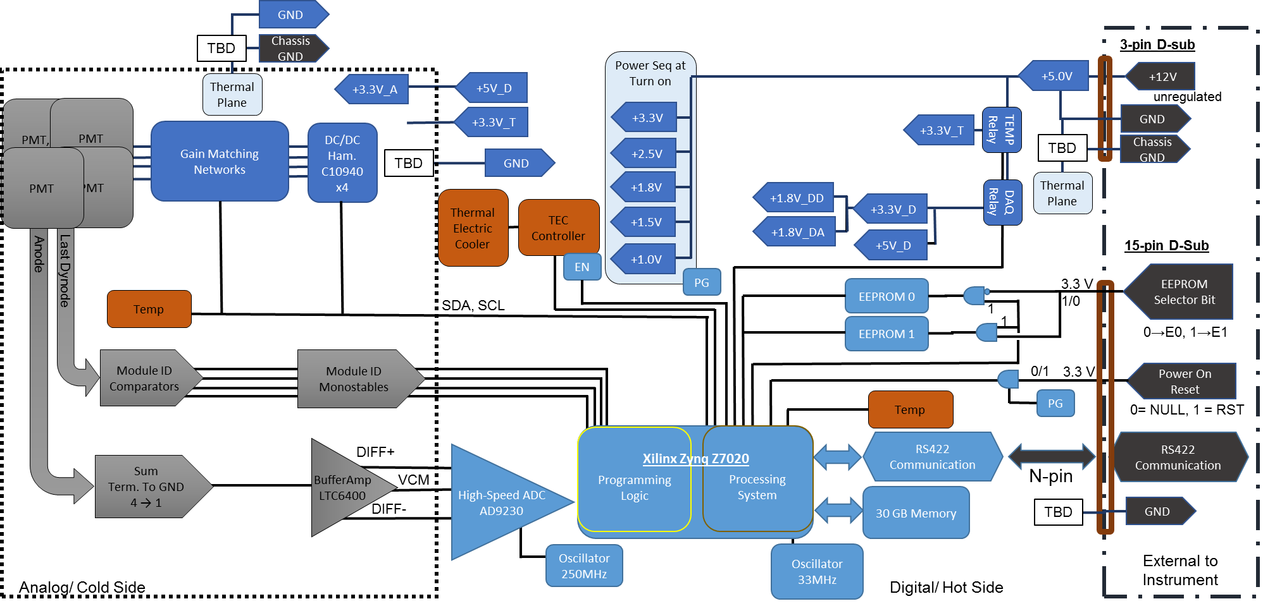

### Transfer Data

The initial energizing of the detector will put the detector into its lowest power configuration. In this configuration, the processor can be configured and data can be transferred to the spacecraft.

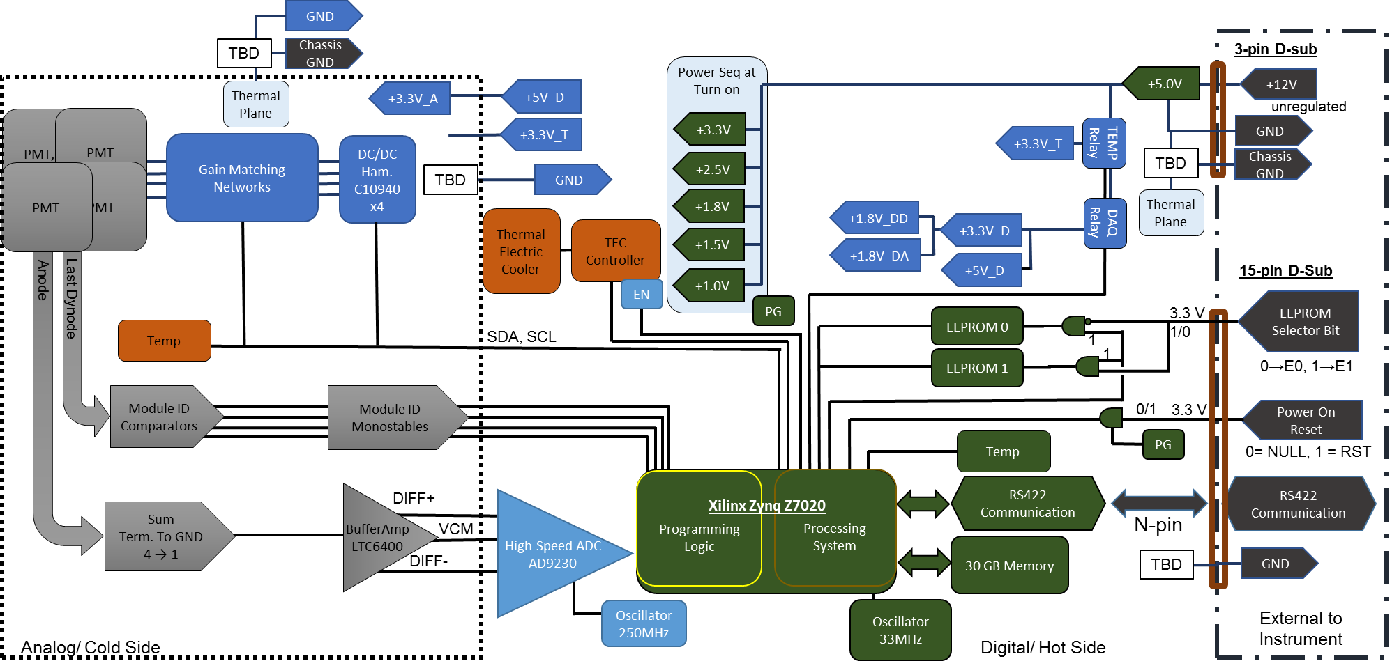

### Setting Temperature

When commands to set the detector temperature are issued, the detector software will energize the thermal control hardware. An attempt to stabilize the temperature will be conducted.

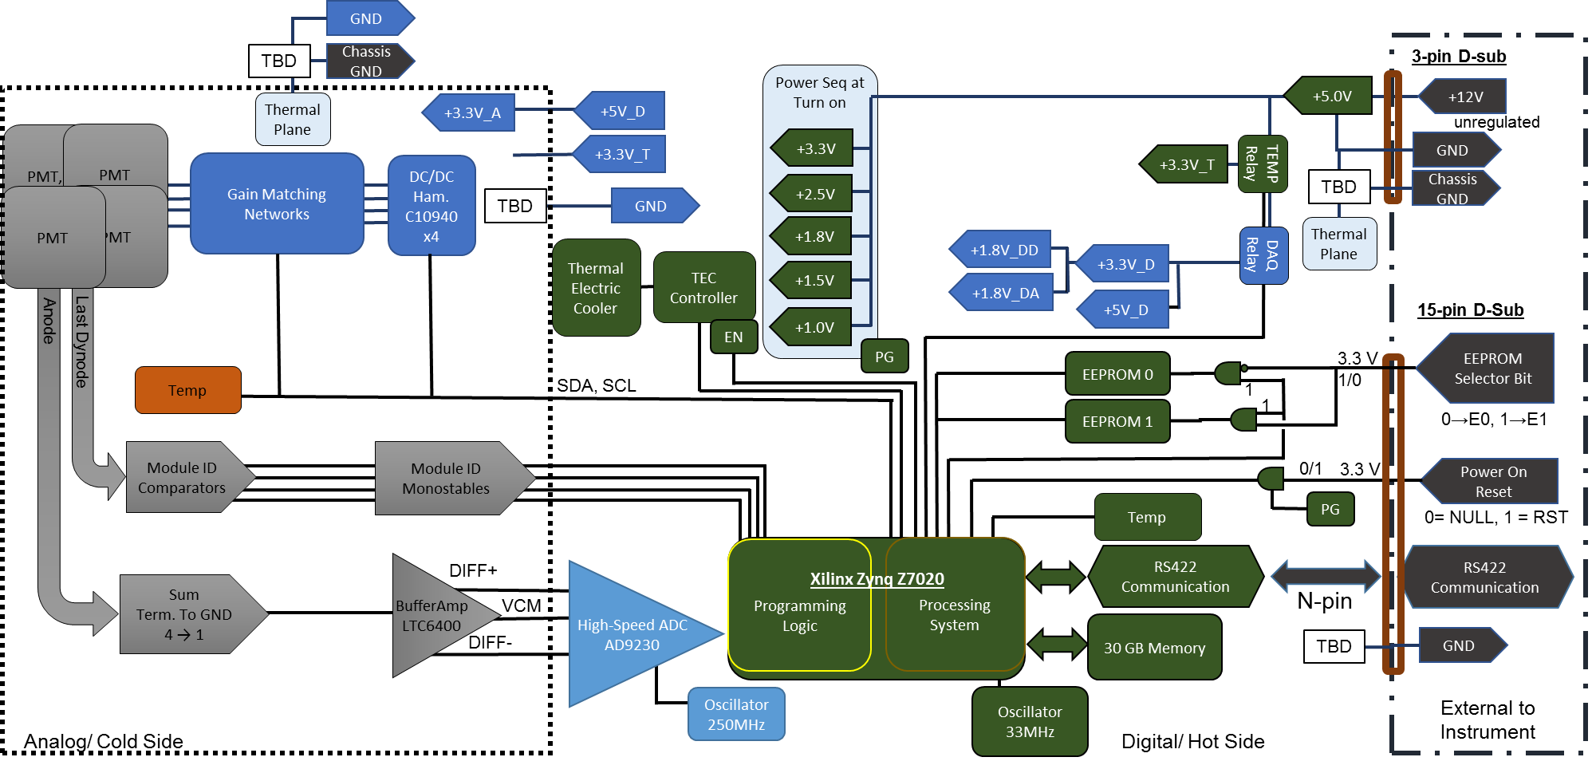

#### Data Acquistion

The issue of a data acquisition command will disable the TEC Controller and enable the detector active elements. TEC may operate in a low current state to mitigate heating from the electronics.

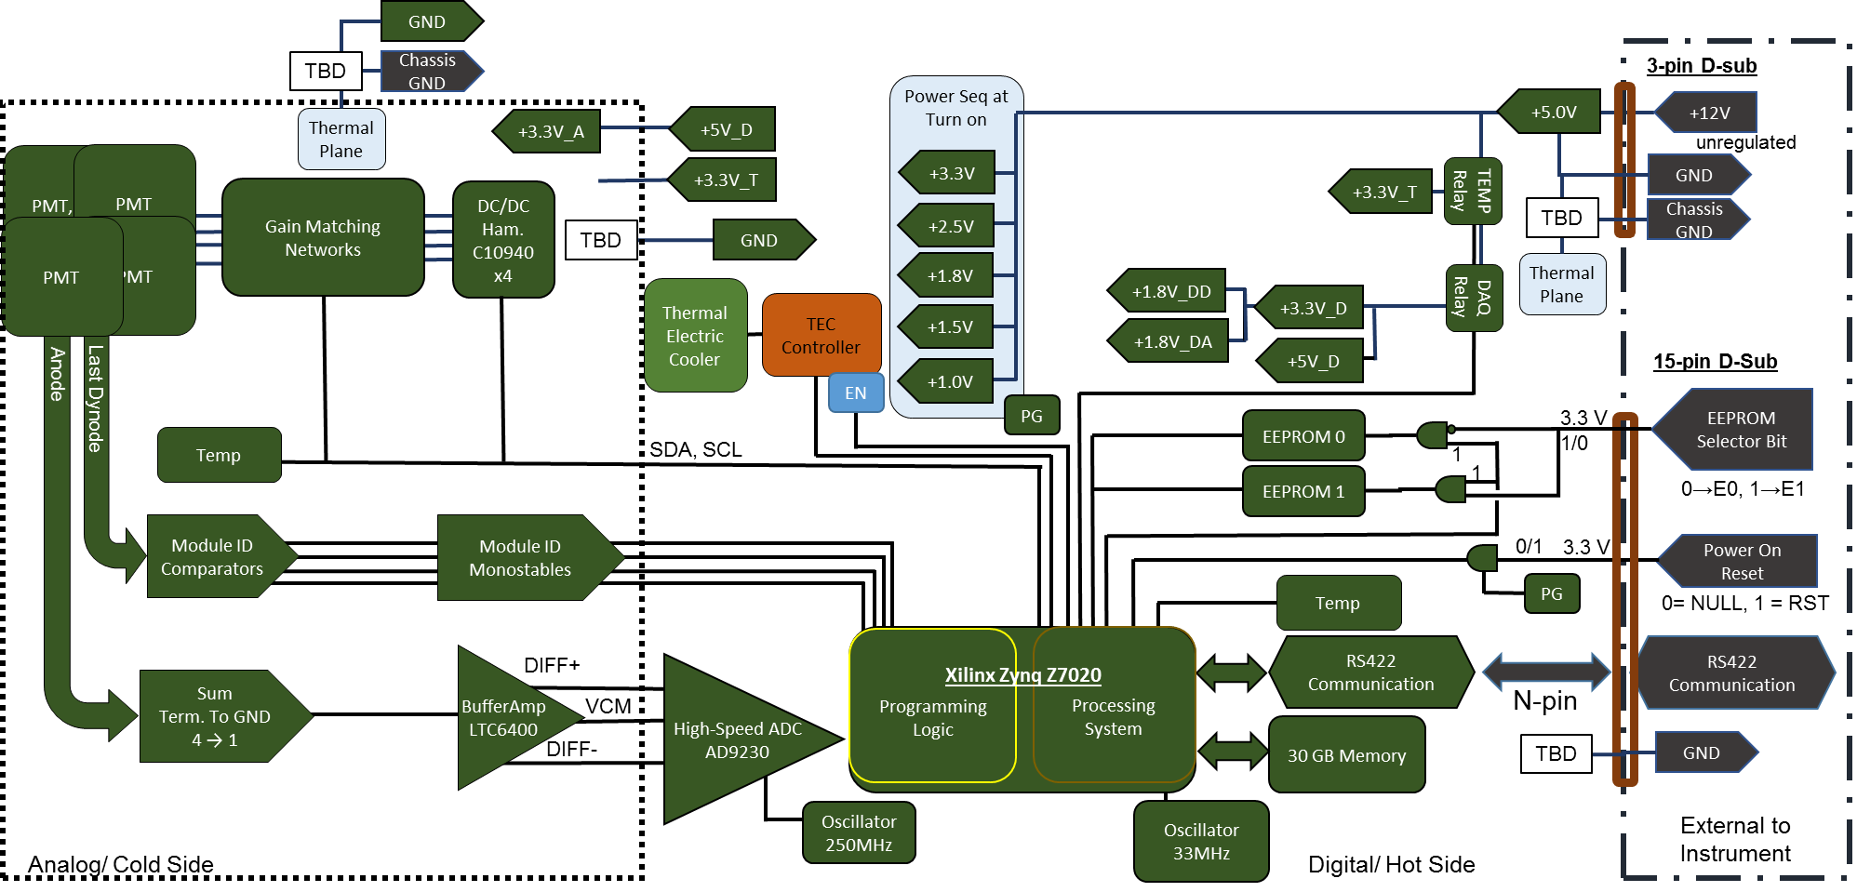

# Development Kit User Manual

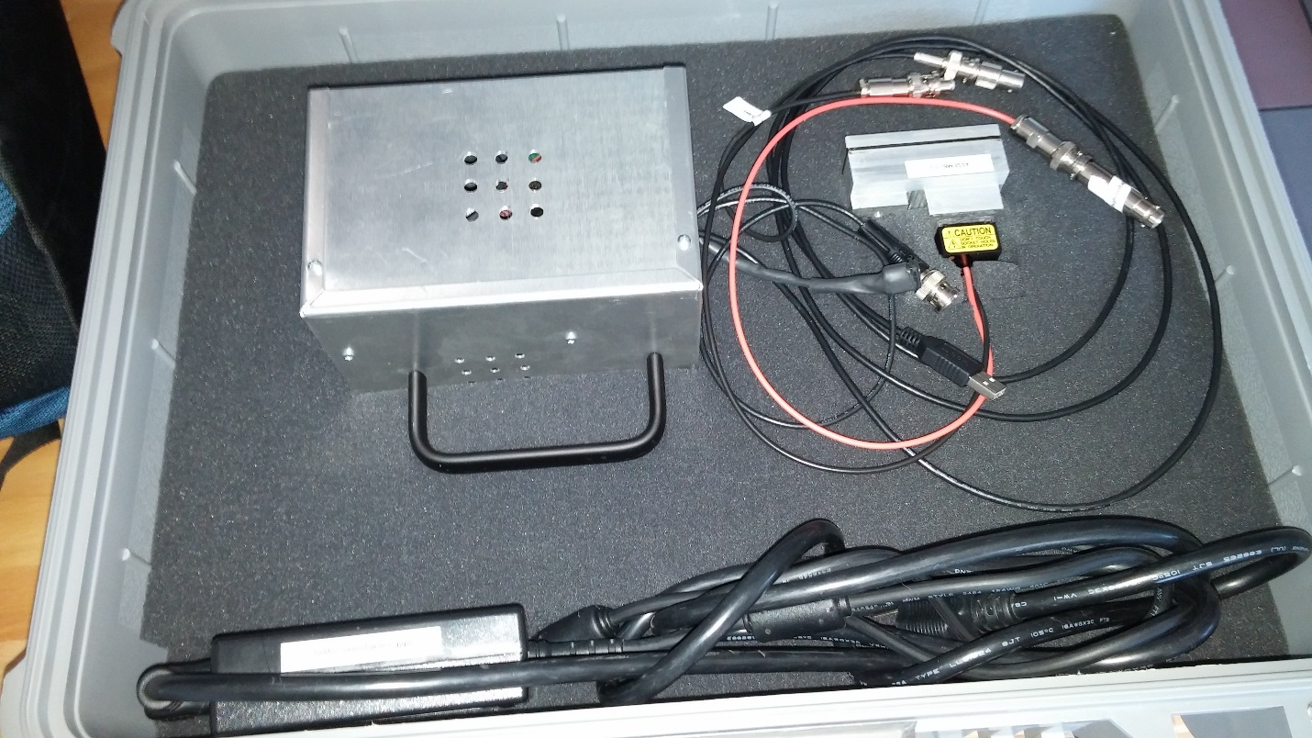

## SetUp:

1. Download TeraTerm

<https://ttssh2.osdn.jp/index.html.en>

1. Click on “Current latest release is 4.91.”

<https://osdn.jp/projects/ttssh2/downloads/65898/teraterm-4.91.exe/>

Executable will be downloaded.

1. Install.
2. Download the USB UART driver

<https://www.silabs.com/products/mcu/Pages/USBtoUARTBridgeVCPDrivers.aspx>

Download and install

1. Plug in USB cable into the computer you will be using.
2. Energize the microZed board by plugging it into the wall.
   1. (Note: The HV cable will have -800V on it. Be warned!)
3. Allow the computer to setup the device.
4. When the setup is complete, turn the power off.

## Collecting Data:

1. Plug in the PMT
2. Attached the Voltage Divider Network
3. Connect the HV cable
4. Connect the signal cable
5. Plug in the USB cable into your computer.
6. Energize the microZed by plugging in the power cable.
7. A green and blue light will illuminate on the board. This Board is inside the box.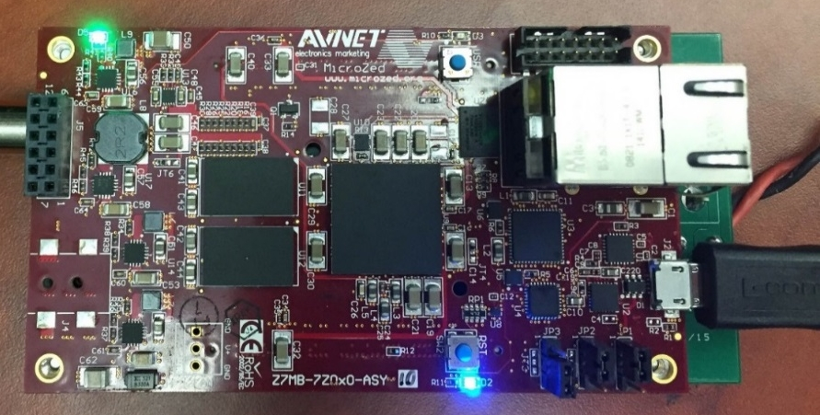
8. Open TeraTerm and connect to the USB Serial Port option
9. This will be a Silicon Labs Labelled Port

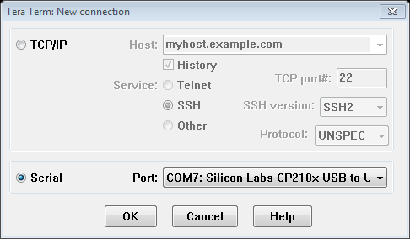

1. Next choose the Setup menu

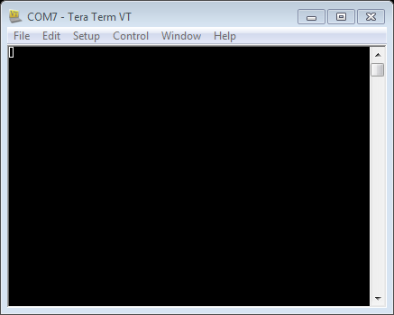

1. From there choose the serial port option which will open this window
2. Change the Baud rate to 115200 and click OK

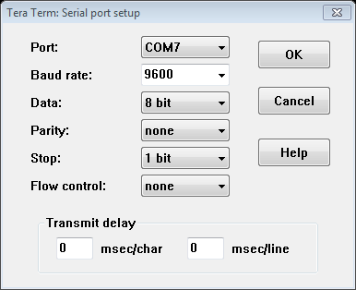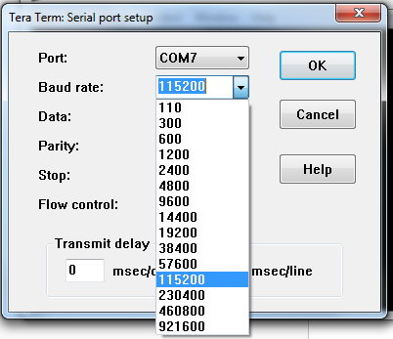

1. Under Setup select “Terminal…”
2. Click on Local Echo

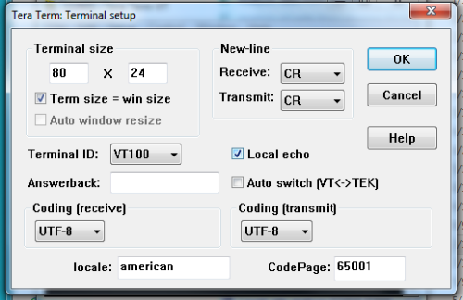

1. Hit <return> to get to the Main Menu  
   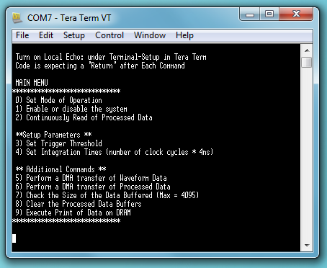
2. Select 0 “Mode of Operation”  
   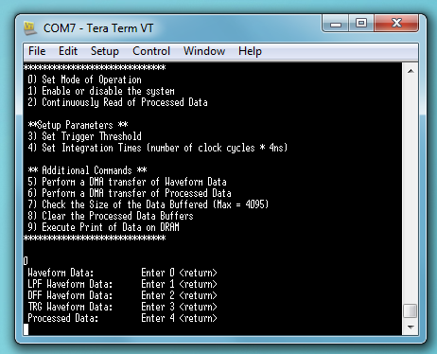
3. Select option 4 Processed Data

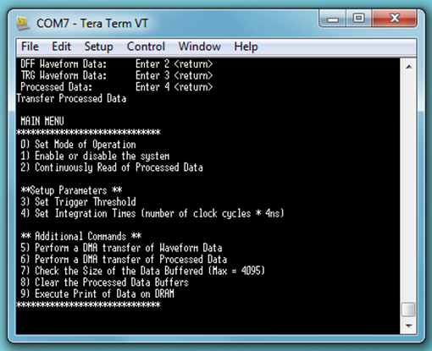

1. Select 1 “Enable or disable the system”

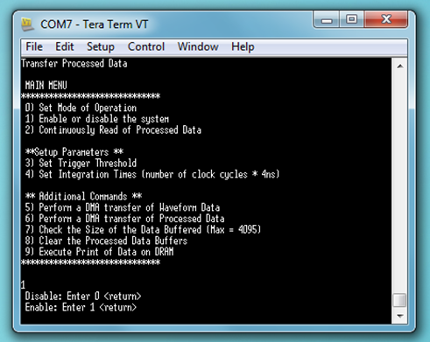

1. Select option 1 Enable

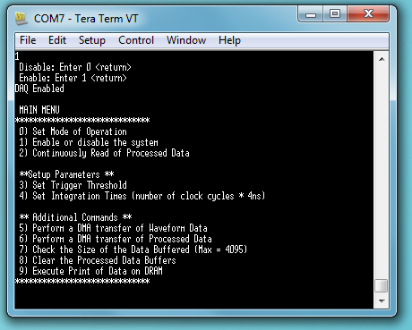

1. Select 2 “Continuously Read of Processed Data”  
   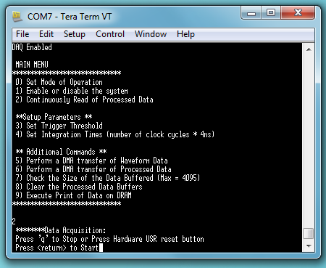
2. Note that pressing “q” at any time will stop the DAQ. There will be some delay at times, but typing “q” once is sufficient.
3. The hardware USR reset button is not accessible while the electronics are inside the box.
4. Setup the log file.
5. Go to File and select Log…
6. Name the file and save it as a .txt file, and make sure that Append and Plain Text options are checked.  
   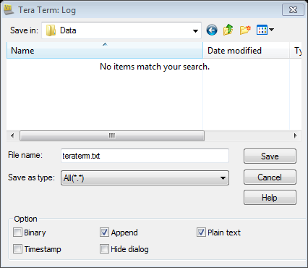
7. The Log will show how much has been saved.  
   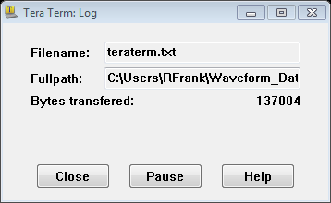
8. Press <return> in the TeraTerm window to start the DAQ.   
   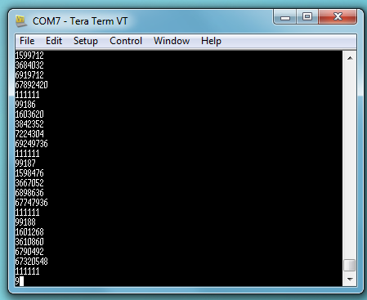
9. At the end of the DAQ. Close the log file.
10. Type “q” in the TeraTerm window.
11. If the system is not powered off, it is still ready to collect data.

DO NOT UNPLUG THE VDN FROM THE PMT WHILE THE SYSTEM IS ON!

DO NOT TOUCH THE PMT WHILE THE SYSTEM IS ON! THERE IS -800 V APPLIED TO THE PMT. ONE OF THE PINS IS AT -800 V WHILE OTHERS ARE AT SOME FRACTION OF -800 V.